Change language to Intermediate Student



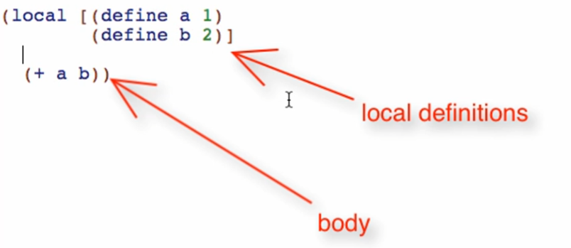

Local definitions

* Exist only INSIDE the local expression

Running that local will produce: 

Another example of local:

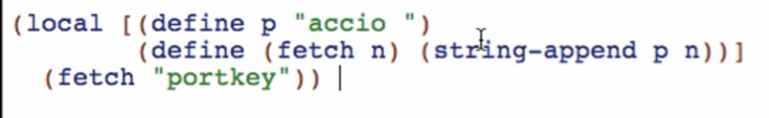

Running this will be:



Top level definition

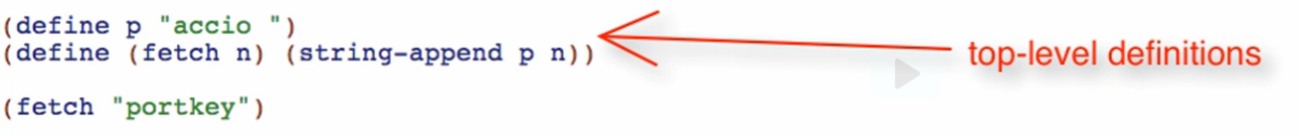



This is like global definitions and invoking a globally defined function

All definitions inside the local will only be valid inside it. You cannot invoke p or fetch outside the local!

Example:

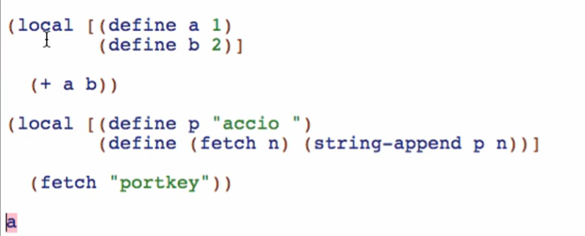



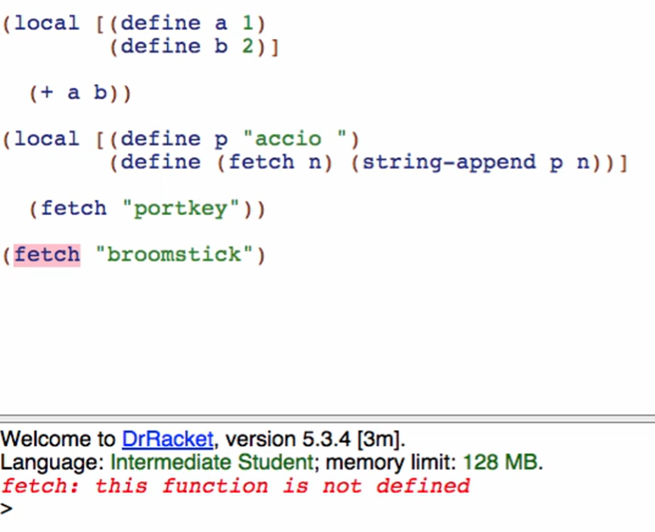

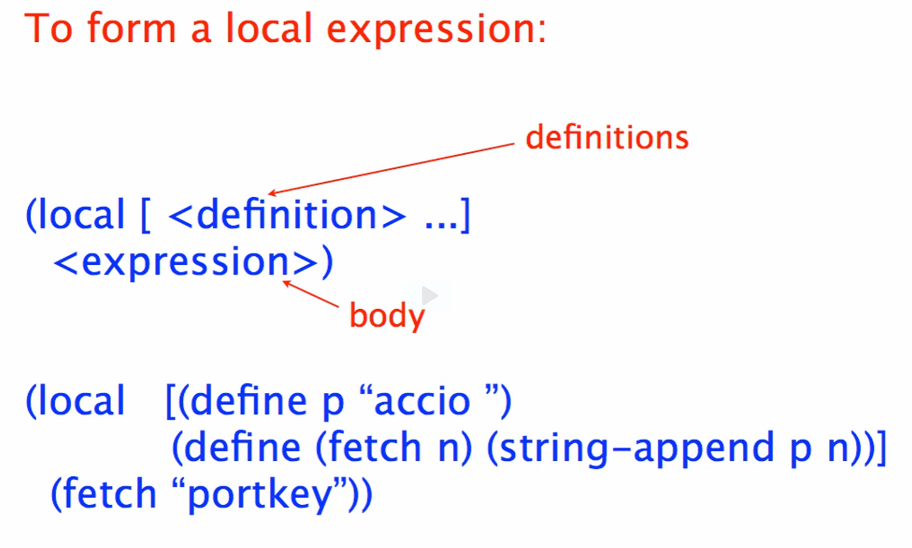

Intuitive way of evaluating the local

1. Sets up the world with those definitions
2. Then evaluates the body and produce a result

Local must have 2 parts:

1. Definitions
   * We can have 0 or more definitions
   * All definitions must be enclosed in a square bracket
2. Body
   * We cannot have an empty body!
   * The body can use or not use the definitions